Geneseo FFA Archery scoring

Small ring = 11

Medium ring = 10

Big ring = 8

Hit the target anywhere else = 5
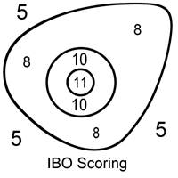

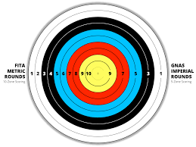

Use this side to score
Olympic style scoring

